**Unity Basics (Part 3)**

**LAB # 3**



**Fall 2024**

**CSE-411L Intro to Game Development Lab**

Submitted by: **Ali Asghar**

Registration No.: **21PWCSE2059**

Class Section: **A**

“On my honor, as student of University of Engineering and Technology, I have neither given nor received unauthorized assistance on this academic work.”

Submitted to:

**Engr. Abdullah Hamid**

Date:

**21st December 2024**

**Department of Computer Systems Engineering**

**University of Engineering and Technology, Peshawar**

**Objective:**

In this we lab we learned further terrain customizations like trees, grass and other plants, how to manipulate wind and make the terrain livelier. Also learned about rigibody and physics material.

**Tasks:**

- Open/create a Unity scene

- Create a terrain of size 100x100, height 500

- Set height of terrain to 250 (move to this height)

- Create mountains on one end of the terrain

- The mountains must be smoothed to have a path between them

- Create a few small spheres with different colored materials

- The spheres must be suspended on top of the path when the game plays they should roll down the path

- Make sure the spheres have rigidbody and bouncy physics

- On the other end of terrain create a forest with grass and flowers

- Create a wind zone so it could look livelier

**Steps:**

1. Open/create a Unity scene

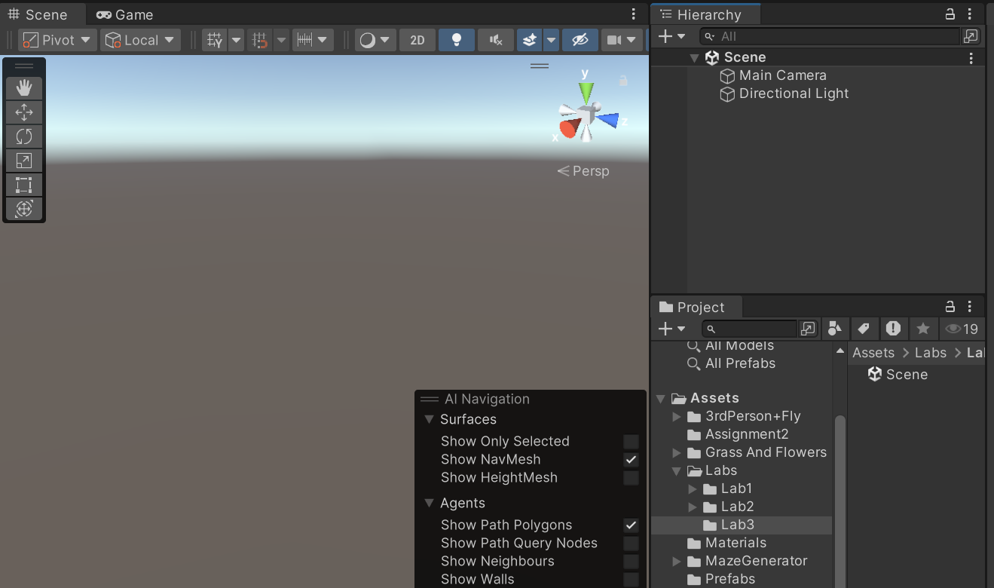

1. Create a terrain of size 100x100, height 500

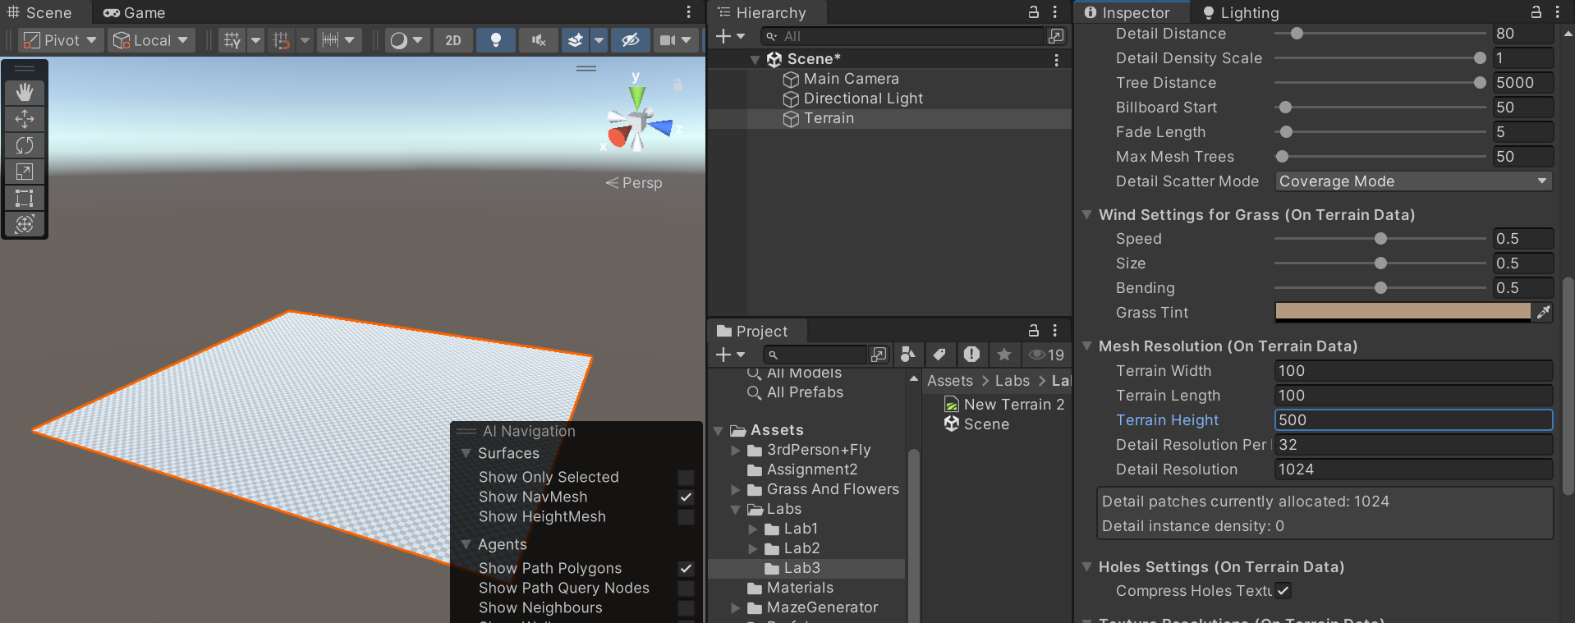

1. Set height of terrain to 250 (move to this height)

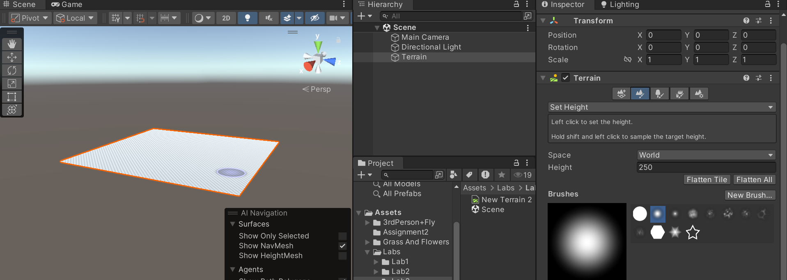

1. Create mountains on one end of the terrain

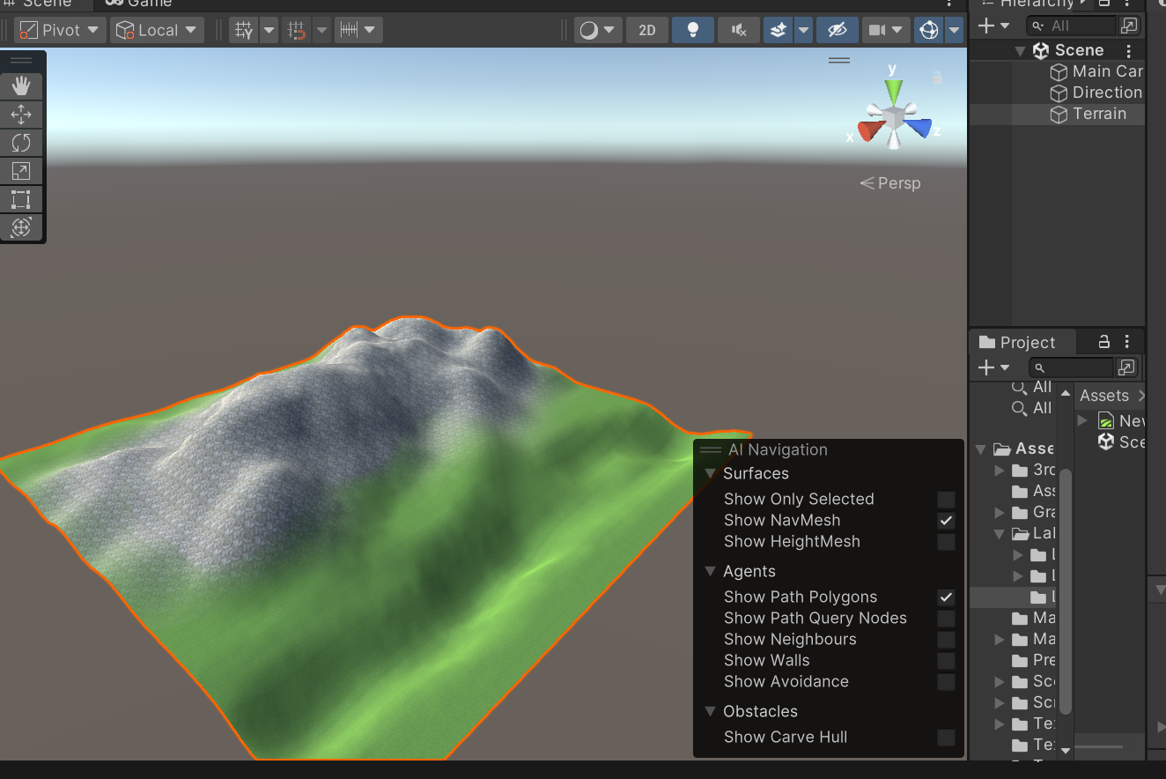

1. The mountains must be smoothed to have a path between them

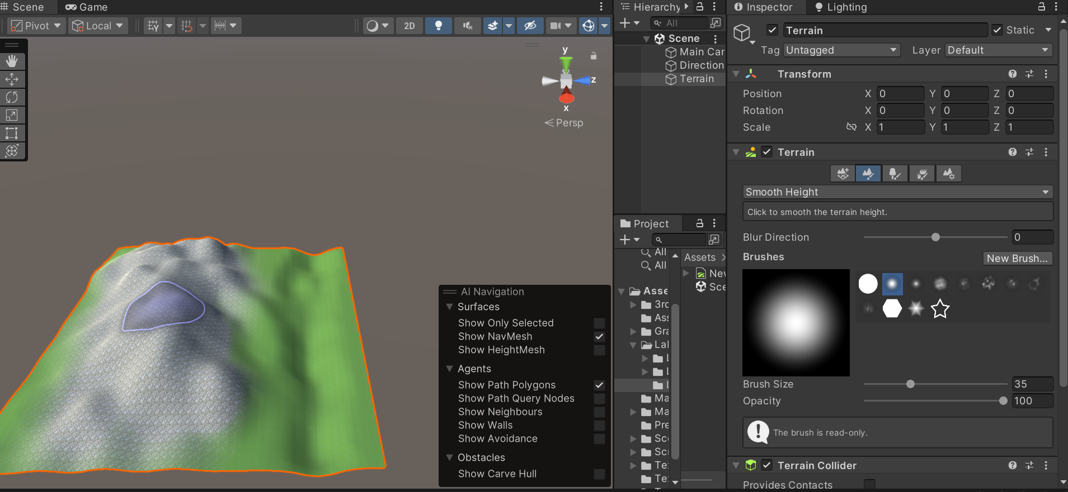

1. Create a few small spheres with different colored materials

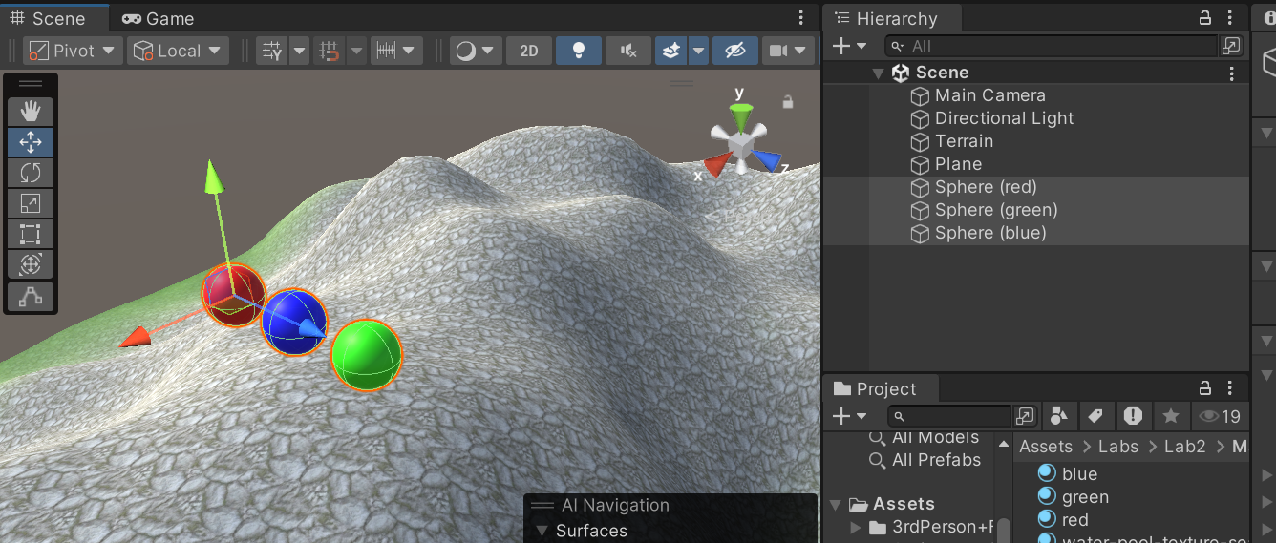

1. The spheres must be suspended on top of the path when the game plays they should roll down the path

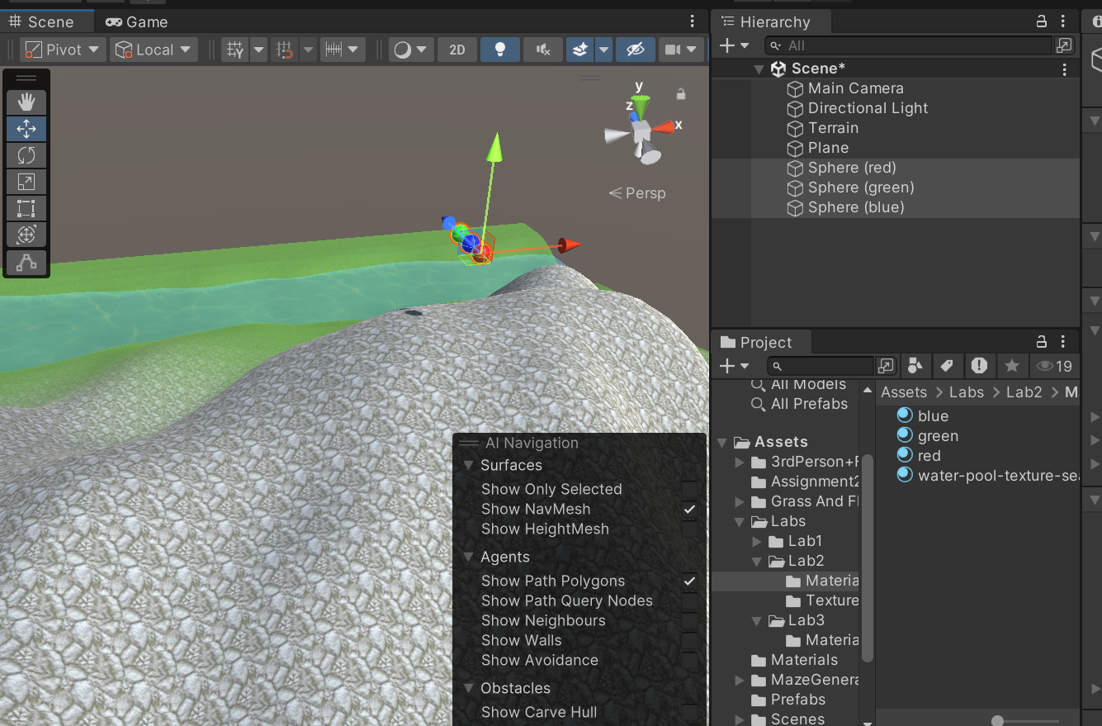

1. Make sure the spheres have rigidbody and bouncy physics

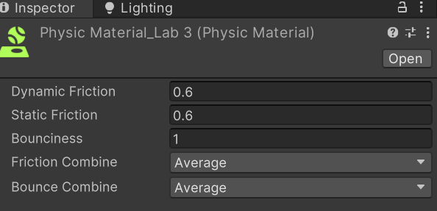

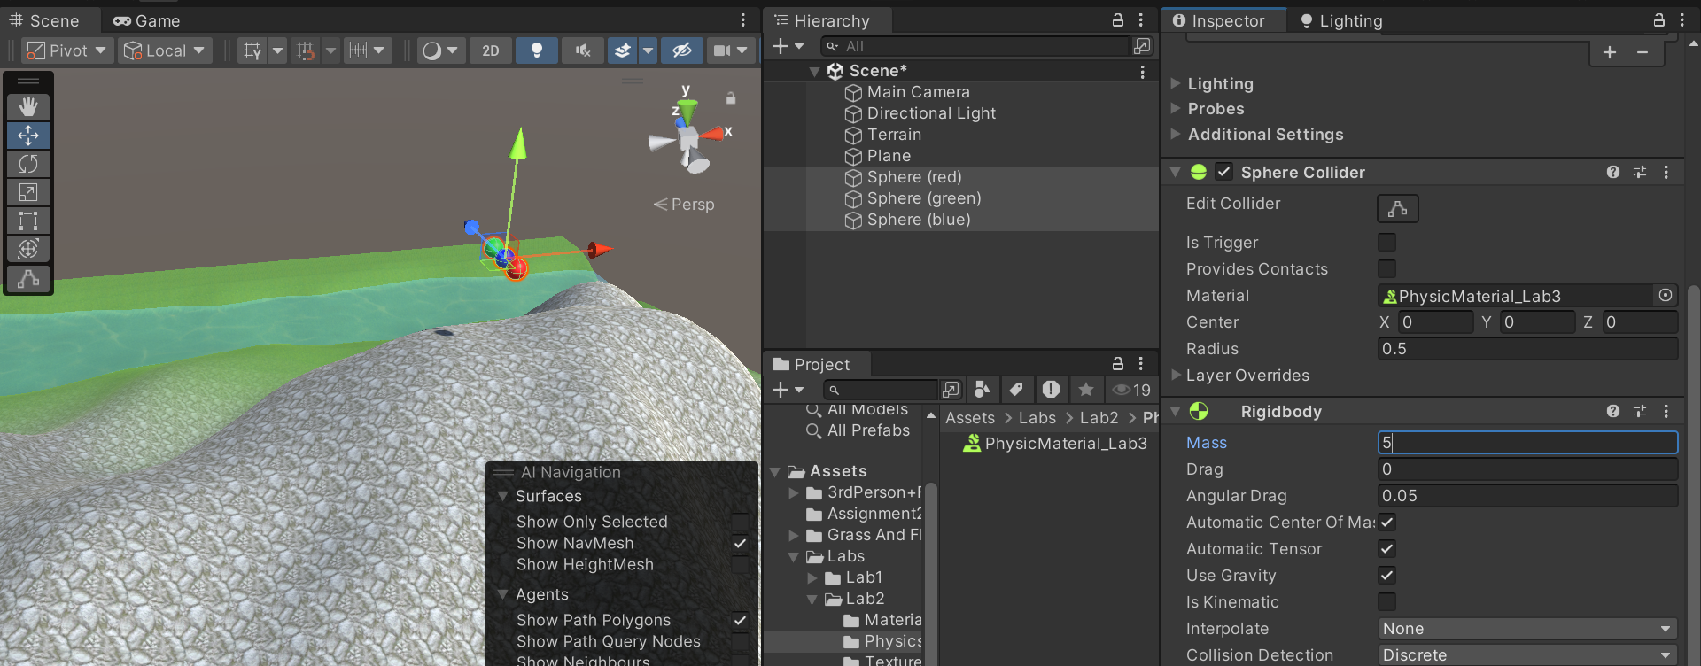

1. On the other end of terrain create a forest with grass and flowers

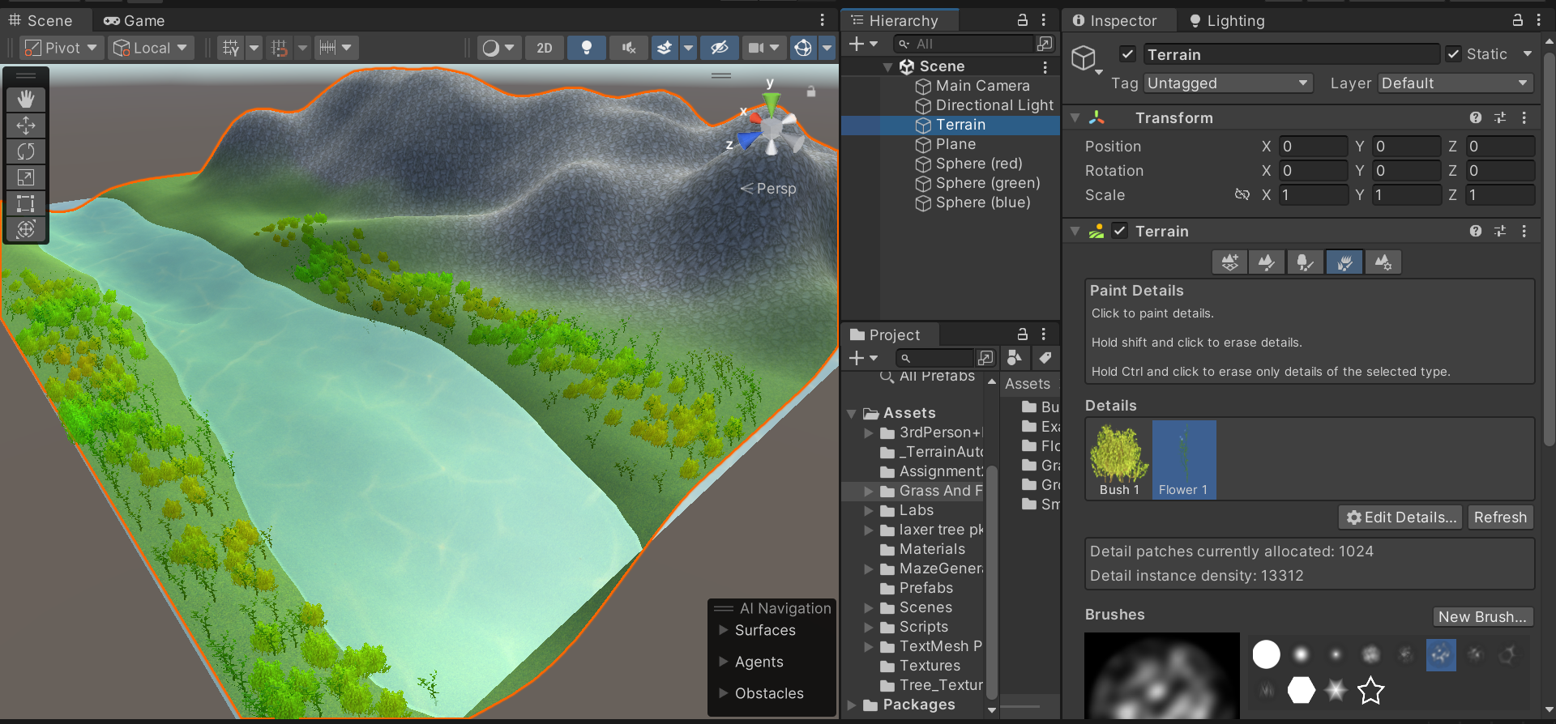

1. Create a wind zone so it could look livelier

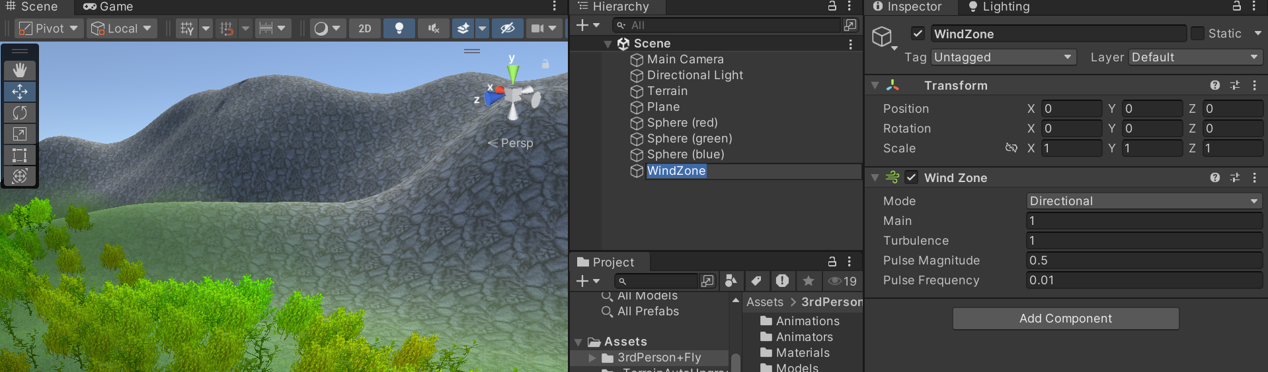

**Final Output:**

